Name:Shantanu Panwar

RollNO:52

Sec :B

University Roll no 1018588

Question2

Server

import java.net.*;

import java.io.*;

public class server2{

public static void main(String[] args) throws Exception{

ServerSocket ss=new ServerSocket(8081);

Socket s=ss.accept();

System.out.println("connection is stable now LOL");

DataInputStream dataRead=new DataInputStream(s.getInputStream());

DataOutputStream dataWrite=new DataOutputStream(s.getOutputStream());

BufferedReader br=new BufferedReader (new InputStreamReader(System.in));

String str="",str2="";

while(!str.equals("bye")){

str=dataRead.readUTF();//reads whatever is sent by the client

System.out.println("Client says: "+str);

str2=br.readLine();

dataWrite.writeUTF(str2);

dataWrite.flush();

}

dataRead.close();

s.close();

ss.close();

}}

Client

import java.io.*;

import java.net.*;

public class client2{

public static void main(String args[])throws Exception{

Socket s=new Socket("localhost",8081);

DataOutputStream dout=new DataOutputStream(s.getOutputStream());

DataInputStream dis=new DataInputStream(s.getInputStream());

BufferedReader br=new BufferedReader(new InputStreamReader(System.in));

String str=" ",str2=" ";

while(!str.equals("bye"))

{

str=br.readLine();

dout.writeUTF(str);

dout.flush();

str2=dis.readUTF();

System.out.println("Server says"+str2);

}

dout.close();

s.close();

}

}

OUTPUT

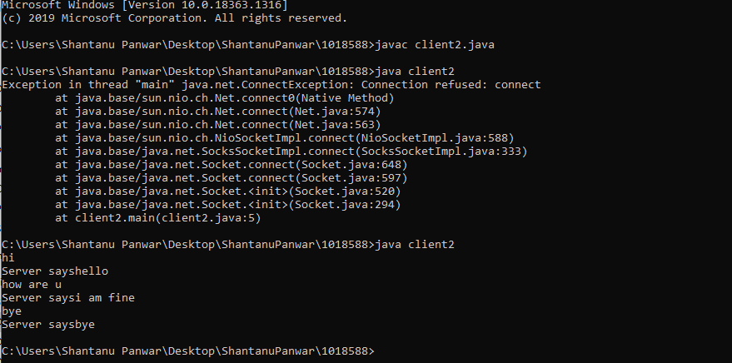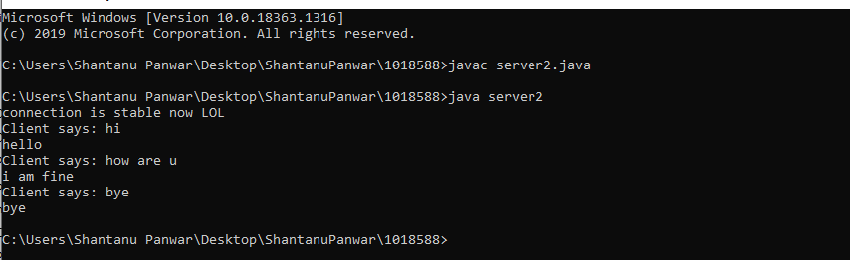

Question 1

package com.java.jdbc;

import java.sql.*;

public class SampleClass {

public static void main(String[] args) throws SQLException {

Connection myConn = null;

Statement myStmt = null;

ResultSet myRs = null;

try {

myConn = DriverManager.getConnection("jdbc:mysql://localhost:3306/jdbcDatabase", "root" , "root@123");

myStmt = myConn.createStatement();

myRs = myStmt.executeQuery("select * from jdbc_tbl");

while (myRs.next()) {

System.out.println(myRs.getString("jdbc_id") + ", " + myRs.getString("title") + ", " + myRs.getString("author") + ", " + myRs.getString("submission_date"));

}

}

catch (Exception exc) {

exc.printStackTrace();

}

finally {

myRs.close();

myStmt.close();

myConn.close();

}

}

}